**Tutorial documentation**

**1. Learning objectives**

In this course, we mainly learn to use STM32F103C8T6 to configure the infrared receiver module and print the key value of the infrared remote control at the serial port.

**2. Prepare before class**

The hardware required is several DuPont lines, STM32F103RCT6 development board, infrared receiver module, and infrared remote control.

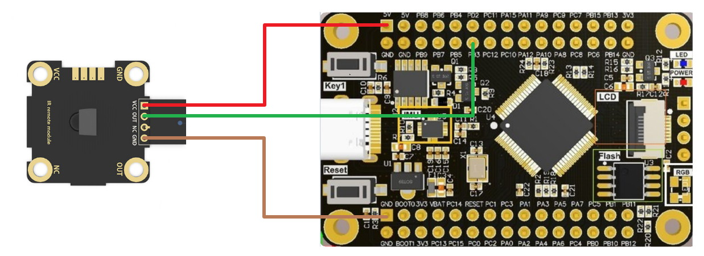

|  |  |
| --- | --- |
| Infrared receiver module | STM32F103RCT6 |
| VCC | VCC |
| GND | GND |
| OUT | PB3 |

1. **Experimental phenomenon**

After the program is downloaded, open the serial assistant and set the relevant parameters. We used the infrared remote control for testing, and we can see the received base 16 key value on the serial assistant.

